ISO 27701 Compliance for Log360
Strengthen data protection and meet ISO 27701 compliance with Log360.
Region: International | Type: Data Privacy, Industry Standard | Category: Compliance | Pricing: Free

Overview
The ISO 27701 compliance extension in Log360 helps organizations meet ISO/IEC 27701:2019, the privacy information management standard published by ISO/IEC that extends ISO 27001 and 27002 for PII controllers and processors establishing a Privacy Information Management System (PIMS) by providing centralized log management, PII access monitoring, and privacy-focused audit reporting. The platform supports ISO 27701 requirements for PII access control, privacy governance, processing activity monitoring, data subject rights support, privacy incident detection, data retention monitoring, third-party processor oversight, and PII transfer controls across cloud and on-premise environments.
For PII Access Control & Authentication, Log360 monitors AD logon events, user auditing records, Windows logon activity, failed authentication attempts, and terminal sessions to detect unauthorized access to PII systems. To address Privacy Governance & Policy Management, the platform monitors Group Policy changes, AD group auditing events, user account changes, and GPO audit records to track enforcement of privacy governance controls across managed systems. The extension also supports PII Processing Activity Monitoring by providing capabilities that monitors process tracking events, file change activities, Windows user access records, and system events to detect unauthorized PII processing activities.

Key Features
- Data Subject Rights Management Support: Log360 monitors file change events, user management activities, AD user auditing records, and Windows user access logs to provide audit evidence of data subject rights actions.
- Privacy Incident Detection & Response: Log360 monitors threat detection events, firewall breach alerts, failed authentication attempts, and system anomalies to identify PII security breaches and privacy incidents.
- Data Retention & Deletion Monitoring: Log360 monitors file change events, process execution records, user access logs, and registry configurations to track PII data lifecycle and detect unauthorized retention violations.
- Third-Party Processor Security Oversight: Log360 monitors AWS IAM activity, unauthorized access events, AWS user activity, Salesforce audit trails, and cloud user logins for third-party processor oversight.


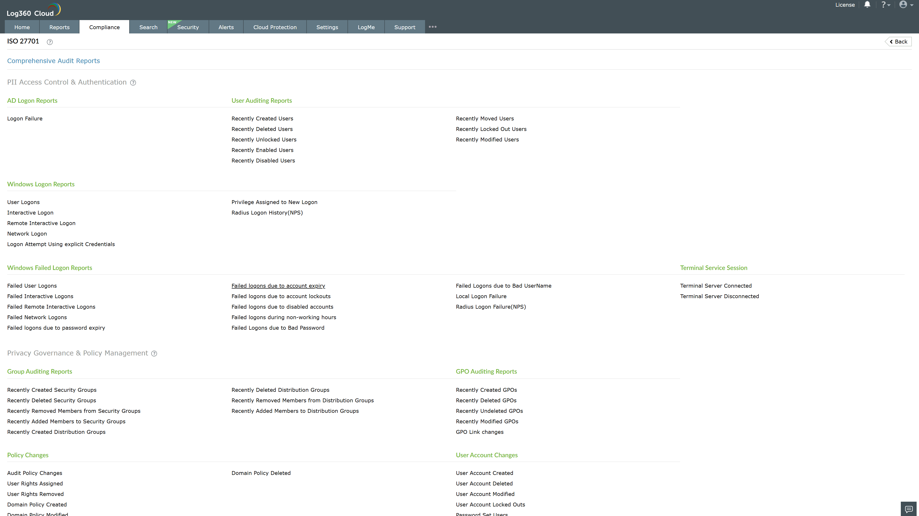
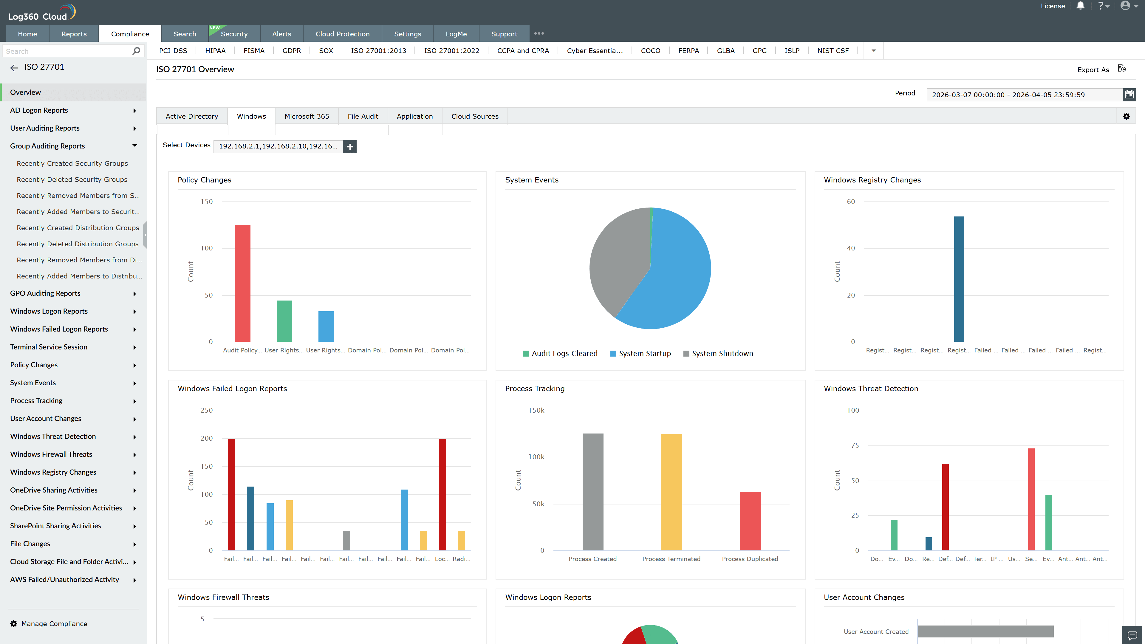
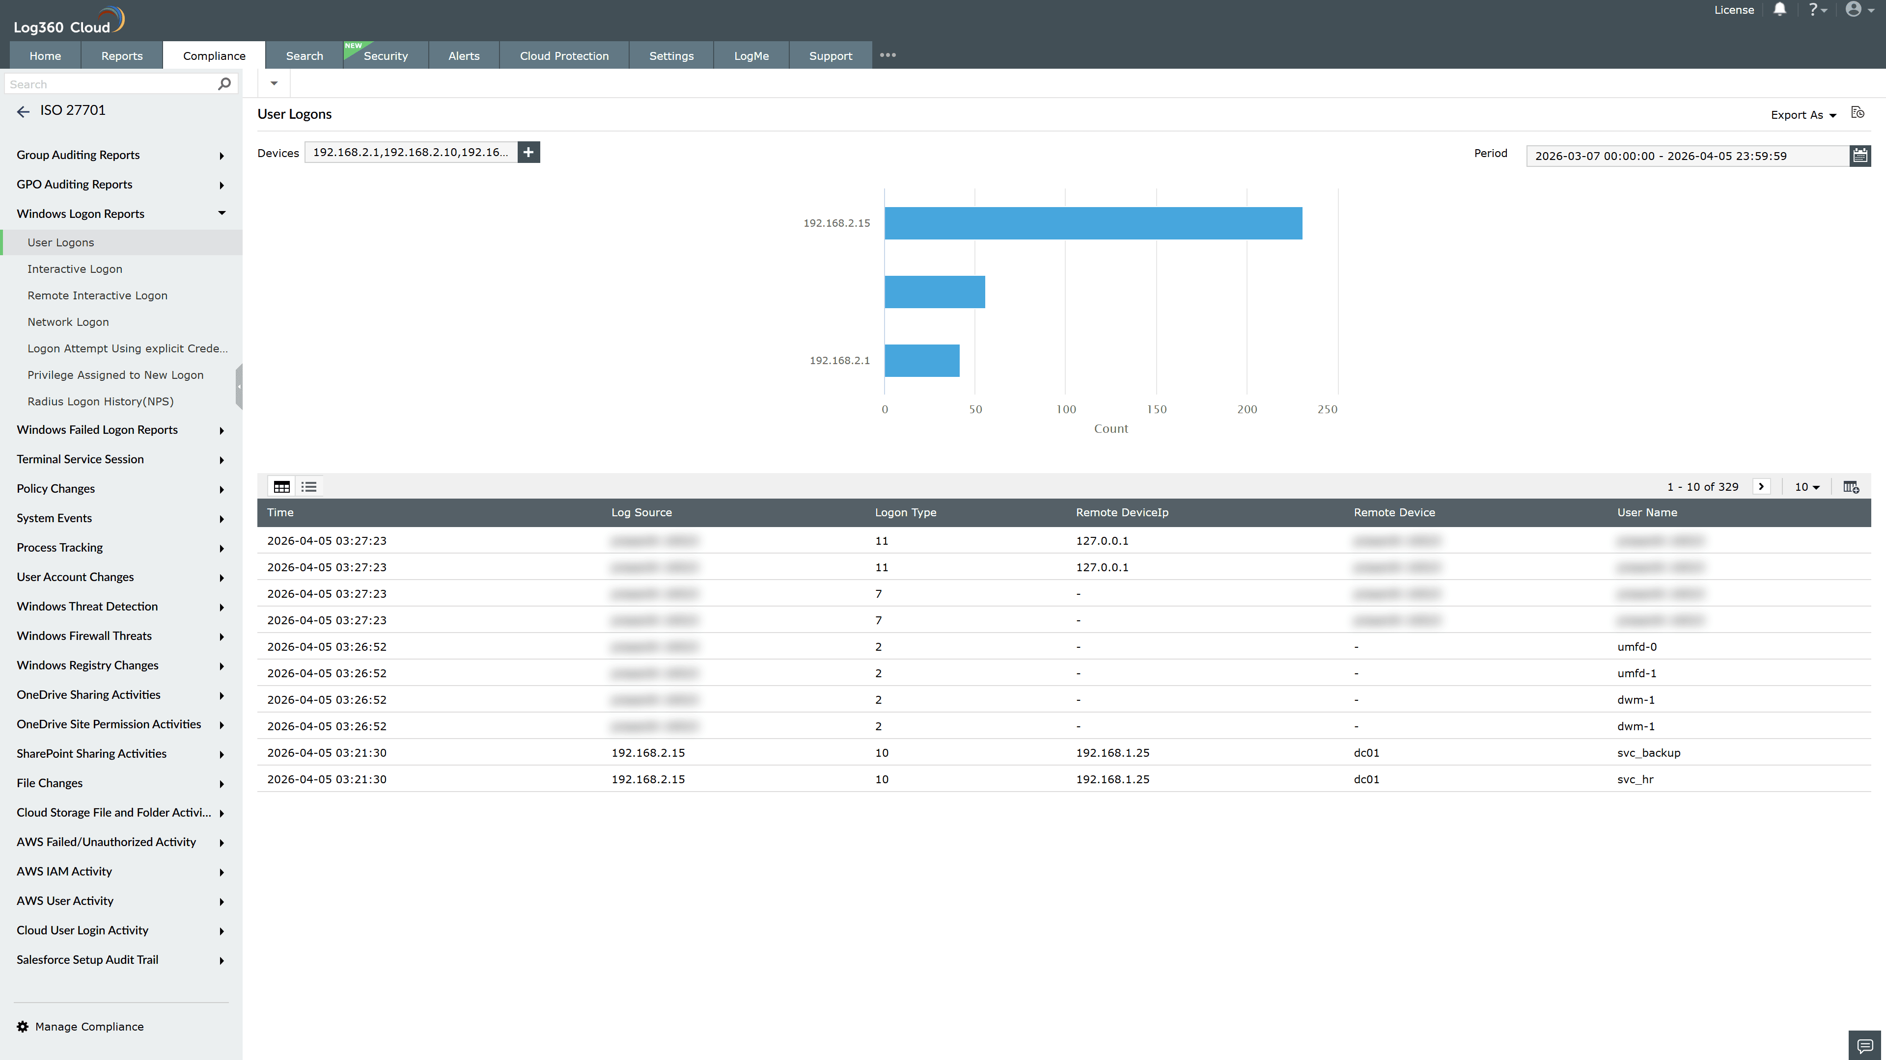
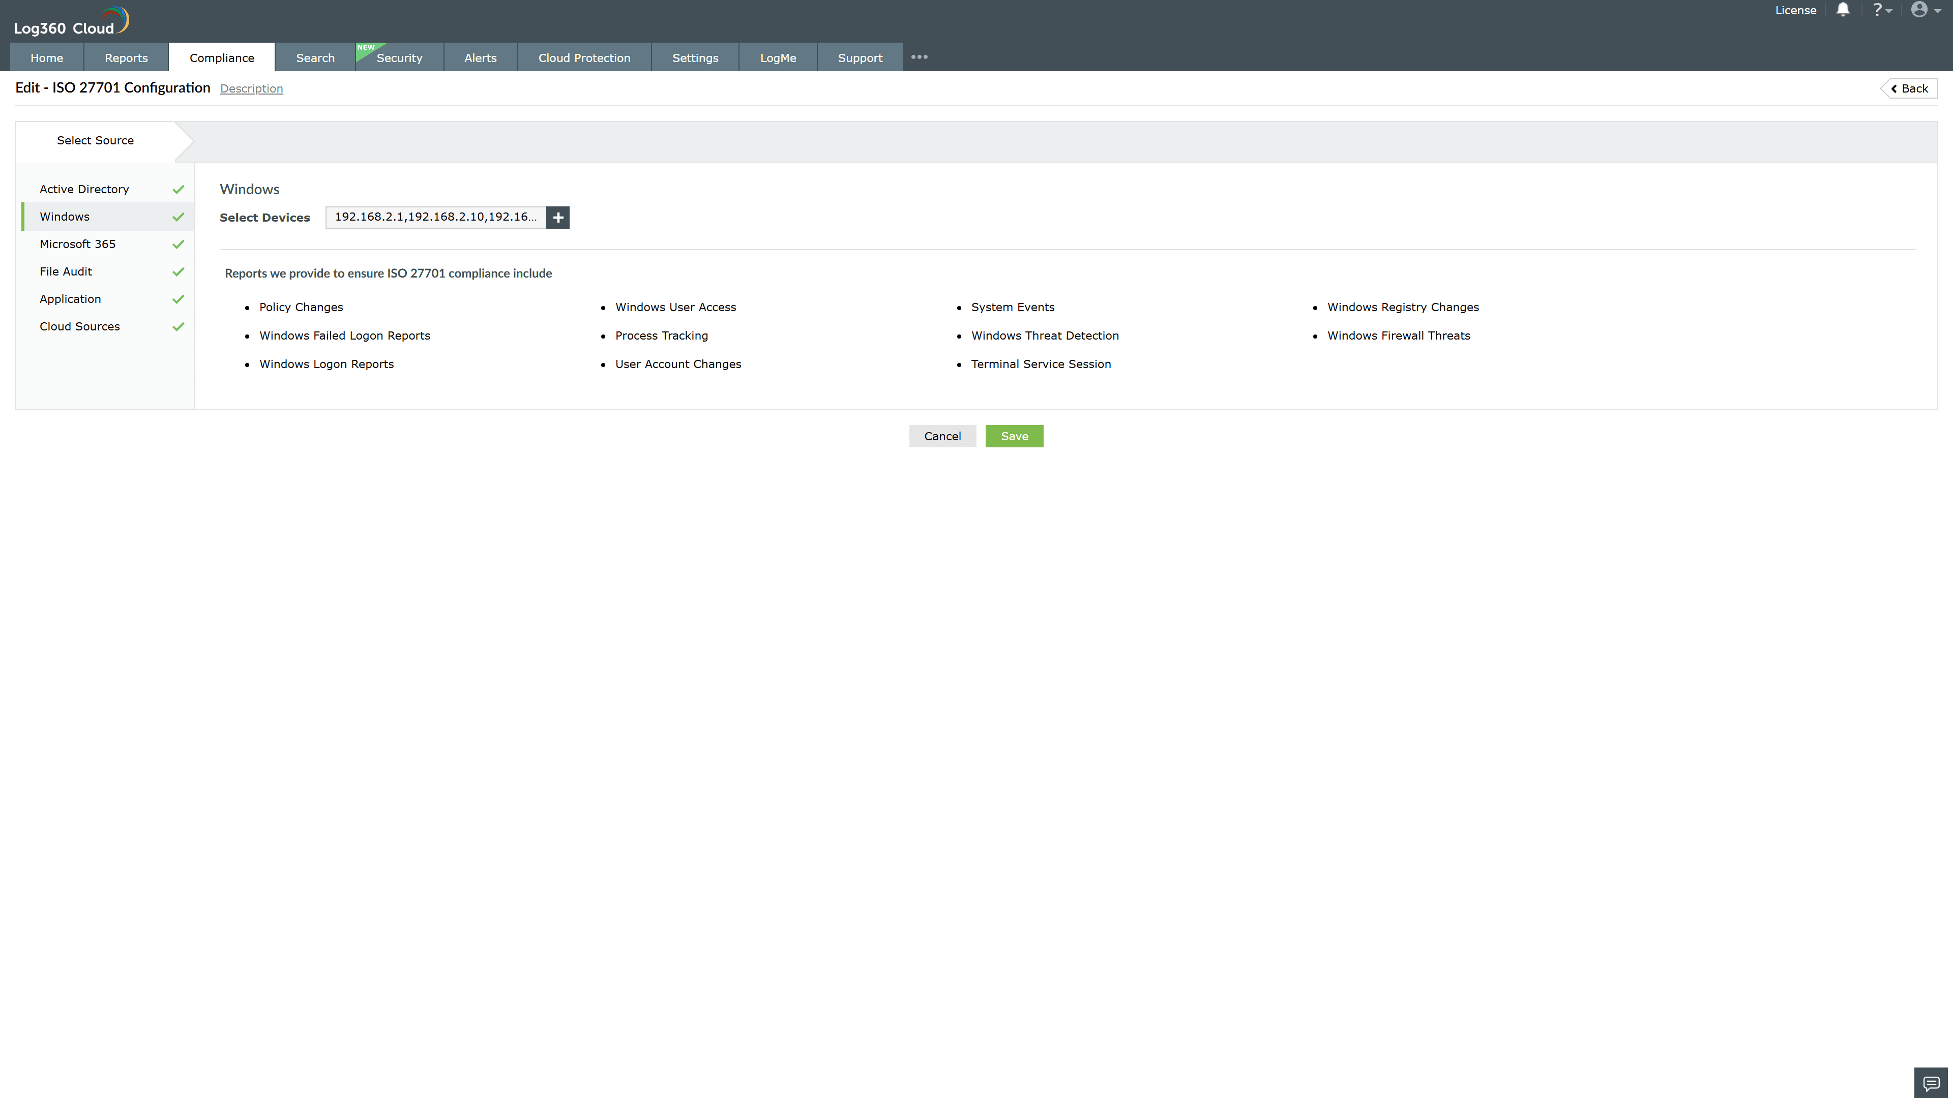
Valid Submission : Yes
Supported Editions : Free, Basic, Standard, Professional, MSSP
Help Document : https://www.manageengine.com/log-management/help/integrations/compliance-extensions.html
Help Video : Not provided
Tags : Log360, Compliance, Privacy monitoring, Data privacy, Regulatory compliance
Supported DCs : US, IN, JP, CA, AU, UK and EU
Privacy Policy:
Terms of Service:
Release Notes:
Predefined reports for the ISO 27701.

